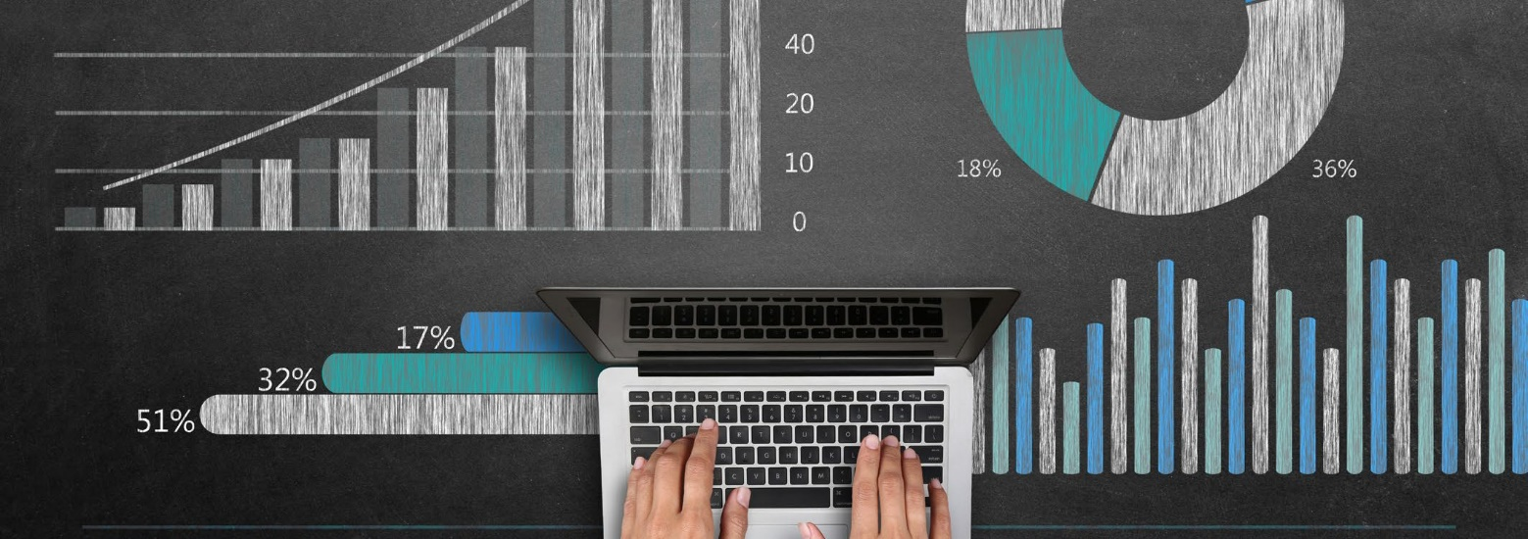

USW Student Guide to Learning Analytics
Version 2, 1st August 2018

“We use data about students and their activities to help understand and improve educational processes, and provide better support to learners. It should be for the benefit of students, whether assisting them individually or using aggregated and anonymised data to help other students or to improve the educational experience more generally.”

This guide aims to explain what the University is doing with Learning Analytics. We want you to understand exactly what data is being collected, how it is being processed and what we will be doing with the information. This document provides these details, and will be updated as our use of learning analytics develops.

What is learning analytics?
The “digital footprints” left when students use Unilearn (USW’s virtual learning environment) and other institutional
systems can be combined with data such as grades and past academic history. We already collect most of the data required, and use it to review aspects of our courses and manage our use of resources more efficiently. However the use of this data for learning analytics is new, and will provide additional information to you, lecturers, tutors and support staff to support your learning journey.

The resulting picture can give you a better idea of how your learning is progressing. It can also help us to understand how we can best support you to meet your goals, and achieve your full potential at USW. During the session 2018/19 we will be trialing some tools for students to see and track their own progress.

Another use for learning analytics is to make predictions by comparing a learner’s patterns of activity and achievement with those of previous groups of students. These can help us to identify those who may be struggling academically.
This information is then analysed and used to:
- Identify a projected outcome and where a student is at risk of withdrawing from their study
- Indicate to the University that a student’s course engagement may have fallen below expectations, so that the lack of engagement process can be initiated.

During 2018/19 we will be running some pilot projects to look at how this might work at USW.

How can learning analytics help my Personal Academic Coach?
The other main way that learning analytics can help is by giving your personal coach better information on your progress. Students will be contacted by their Personal Academic Coach to arrange a meeting to review your progress. Personal Academic Coaches have access to a system called Data Explorer, which has data about your engagement and attainment, and can be used to provide a focus for conversations between the two of you.

What data is being collected for learning analytics?
The following data is being used for learning analytics:

- Background information: your name, identifiers used by the University, date of birth, gender, your socio-economic background, whether you are an overseas student, contact details, and a link to the photo we hold of you
- Details about your course, the modules you are taking, and your tutors
- Details of your assessments, marks and grades obtained
- Details of your activity in Unilearn: logins, resources viewed, assessments submitted and graded, and session timeouts
- Attendance records from some systems
- Usage details about some Library resources

Is my personal information safe and secure?
Your data is subject to strict security procedures in compliance with the Data Protection Act 2018. Only those members of staff who have a professional requirement to support you are permitted to view the analytics about you individually. In particular, your personal tutor will be able to view data about your engagement and attainment. If you have any concerns about the University using your data for the purposes of Learning Analytics, do discuss these with your personal tutor.

Your data is also combined with data about other students to help us improve our courses and to support students better overall. This data is not individually identifiable. It is first “de-identified” i.e. fields such as your student ID are encrypted. It is then sent to a central learning records warehouse managed by the University’s contracted agents, and hosted on servers in physically secure, multi-tenanted private cloud arrays in the European Economic Area.

